Electronic control unit (ECU)

Digital technology furnishes an extensive array of options for open and closed-loop control of automotive electronic systems. A large number of parameters can be included in the process to support optimal operation of various systems. After receiving the electric signals transmitted by the sensors, the ECU processes these data in order to generate control signals for the actuators. The software program for closed-loop control is stored in the ECU’s memory. The program is executed by a microcontroller. The ECU and its components are referred to as hardware. The ECU contains all of the algorithms for open and closed-loop control needed to govern the engine-management processes (ignition, induction and mixture formation, etc.)

# Operating conditions

The ECU operates in an extremely harsh and demanding environment.

It is exposed to

* Extreme temperatures (ranging from – 40 to + 60...+ 125 °C) under normal operating conditions
* Abrupt temperature variations
* Exposure to fluids (oil, fuel, etc.)
* The effects of moisture and
* Mechanical stresses such as engine vibration

# ECU Architecture

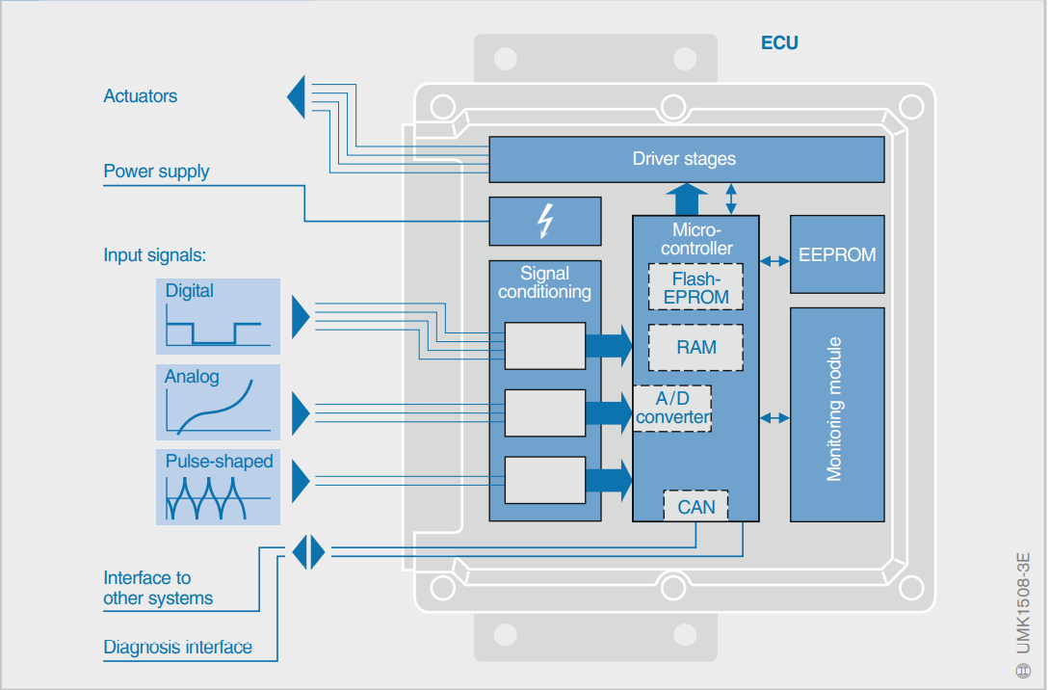

# Types Of ECUs

* Engine control module (ECM)
* Powertrain control module (PCM)
* Transmission control module (TCM)
* Brake control module (BCM or EBCM)
* Central control module (CCM)
* Central timing module (CTM)
* General electronic module (GEM)
* Body control module (BCM)
* Suspension control module (SCM).

